**EXERCISE 6**

1) Write shell script to show various system configuration like  ∙ Currently logged user and his log in name

∙Your current shell

∙Your home directory

∙Your operating system type

∙Your current working directory

**CODE**

echo

echo "--------------------------------------------------"

echo "Currently logged user is:"

echo "--------------------------------------------------"

echo

who

echo

echo "--------------------------------------------------"

echo "Current shell is:"

echo "--------------------------------------------------"

echo

ps

echo

echo "--------------------------------------------------"

echo "Home Directory:"

echo "--------------------------------------------------"

echo

eval echo $USER

echo

echo "--------------------------------------------------"

echo "Operating system type:"

echo "--------------------------------------------------"

echo

lsb_release -a

echo

echo "--------------------------------------------------"

echo "Currently working directory is:"

echo "--------------------------------------------------"

pwd

**OUTPUT**

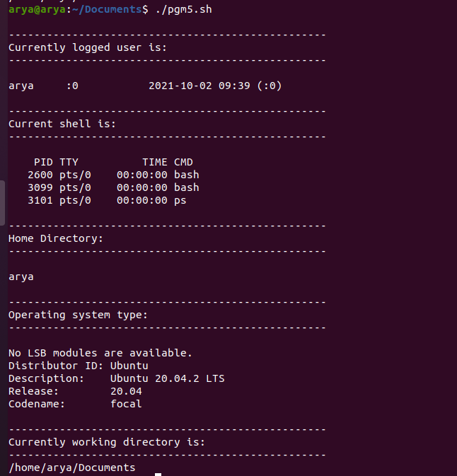

2) Write shell script to show various system configurations like

• your OS and version, release number, kernel version

•all available shells

• File system (Mounted)

**CODE**

echo

echo "---------------------------------------------------------"

echo "OS and version, release number, kernel version"

echo "---------------------------------------------------------"

echo

cat /etc/os-release

echo

echo "---------------------------------------------------------"

echo "Available shells"

echo "---------------------------------------------------------"

echo

cat /etc/shells

echo

echo "---------------------------------------------------------"

echo "File system (Mounted) "

echo "---------------------------------------------------------"

echo

df -h

**OUTPUT**

